**Collagen paper: revised version, 25 October 2018**

**Is collagen quantity and properties involved in wrinkle formation and follicle development of Merino sheep ?**

**Abstract**

Comparative studies of the quantity and type of dermal collagen, and related follicle and fibre properties, of Merino sheep visually selected as having either wrinkly skins or loose and supple (non-wrinkly) skins are reported.

All of the sheep with wrinkly skins had thick, enmeshed sheets of mainly hard (Type I) collagen fibrils in the papillary dermis below the follicles and surrounding the follicle bulbs. This hard collagen layer was thick and continuous throughout the skin with no difference in collagen content or type measured for samples collected “on wrinkles” or “between wrinkles “. The follicle groups were severely disrupted. The follicles were highly curved, long and uneven in length. The secondary fibres were high in mean fibre diameter, and highly variable in fibre diameter and fibre length.

Virtually no hard collagen was detected in the dermises of non-wrinkly sheep with loose and supple skins. The collagen was mainly soft (Type III) and the fibrils were arranged as reticular patterns of thin sheets. The follicle groups were well-defined and arranged in orderly, well-spaced rows. The sheep had high numbers of secondary follicles per group, and high follicle densities. The follicles were straight, short and uniform in length. The primary fibres and secondary fibres were fine and uniform in diameter and uniform in length.

It appears that hard collagen in the foetal skin, and subsequently, leads to wrinkle formation and follicle disruption. Hard collagen may also impair secondary follicle initiation and fibre development.

Wrinkles appear as vertical lines overlapping and descending from the origin points of the spinal nerves, conforming to the dermatome patterning established in embryogenesis.

**Introduction**

Most Merino sheep have wrinkly skins. Wrinkles are raised and often hardened areas of skin which appear to form when the epidermis, papillary dermis and reticular dermis buckle up into a fold(Figure 1).

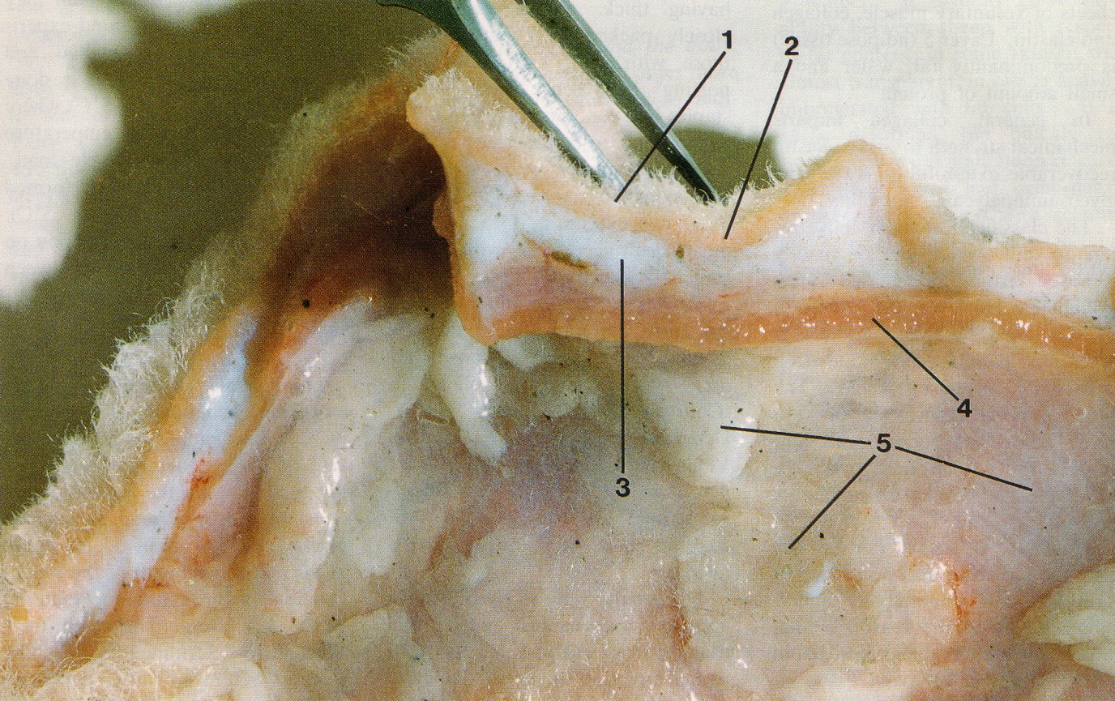

**Figure 1. Merino sheep skin showing layers. 1. epidermis with wool fibres; 2. papillary layer of dermis, 3. reticular layer of dermis; 4. areolar tissue and muscle; and 5. adipose tissue. Two wrinkles are present; one alongside each side of the forceps (from Mitchell et al, 1984).**

Jackson and Watts (2018) proposed that wrinkles form when a lot of follicles initiate the upper papillary dermis, causing this layer to expand considerably, and at the same time, a lot of hard collagen fibrils form in the papillary dermis below the follicle bulbs, binding the dermis against expansion. The conflict between these two tensions is thought to cause the epidermis and dermis to fold and a wrinkle to be formed.

Collagen is the major component of connective tissue of the skin. It is present in foetal sheep skin at 75 to 80 days; the time when wool follicles develop (Knight et al 1993). These authors distinguish two collagen types, namely Type III or ‘soft collagen’ and Type I or ‘hard’ collagen. They report that Type III collagen is highest at 75 days of gestation, and falls progressively as the foetus develops, while Type I collagen is low at day 75 and rises to over 50 percent by birth.

Collagen fibrils are formed from cells called fibroblasts. At 75 to 80 days of foetal life, the fibroblasts are plump, immature cells surrounded by a fine, reticular pattern of collagen fibrils which are composed of Type III collagen. By birth the fibroblasts have matured and the collagen fibrils may be enmeshed to varying degrees. If the fine, reticular pattern of fibrils remains, it appears to be soft collagen and skin wrinkling does not seem to develop. If the collagen fibrils enmesh, lengthen and thicken, the collagen tissue appears to be hardened.

Wool follicles also derive from fibroblasts that have transformed into prepapilla cells in the foetal skin (Moore et al, 1989; Moore et al, 1998). Primary follicles initiate first, from about 65 days of gestation and secondary original follicles follow at 85 days; both as downgrowths of epidermal tissue into the dermis at pre-determined initiation sites. Secondary derived follicles initiate at 110 days until shortly after the birth of the lamb at 145 days as branches of secondary original follicles. Moore et al (1989, 1998) propose that wool follicle patterning is determined by the number and distribution of prepapilla cells.

Bogolyubsky (1940) observed that wrinkles appear in the foetal skin of Merino and Karakul lambs at about 100 days of gestation; first on the dorsal surface and then extending down the sides to the belly. This time frame coincides with the period when secondary derived follicles initiate. Developing wool follicles that encounter hard collagen sheets in the dermis, may grow in a curved shape and the arrangement and shape of follicle groups may be distorted. Nay (1966) recognised that Merino sheep with tangled or curved follicles have more distortion of the follicle groups and a poorly organised network of skin blood vessels compared with sheep with straight follicles (Nay 1966). The genetic correlation of wrinkle score with follicle curvature is very high (0.69 with 95 percent confidence limits 0.65-0.74) (Jackson 2017) which suggests, but does not prove, that collagen is the linking factor.

Curved follicles grow curved fibres, with a greater proportion of paracortex, and a more highly keratinised paracortex. The rate and type of fibre growth is a question of the way the bulb cells differentiate to form the fibre cortex in straight versus curved follicles. In curved follicles there is more bilateral asymmetry in the fibre cortex (Mercer, 1950). If there is more keratinisation it means bulb cell differentiation into fibre proceeds for longer, so the fibre length growth rate would be slower.

If Jackson and Watts’ hypothesis is correct, we expect to see:

* wrinkled sheep to have more or harder collagen in the dermis
* sheep with more or harder collagen to have curved follicles and disruption to the arrangement of follicle groups
* sheep with curved follicles to grow curved fibres with a more radical segmentation of orthocortex and paracortex
* sheep with curved follicles to have lower fibre length growth rate
* sheep with curved follicles to have a higher secondary fibre diameter
* sheep with more or harder collagen to have follicles of uneven depth
* sheep with follicles of uneven depth may have greater variability of secondary fibre diameter.
* sheep with curved and unevenly seated follicles to have more fibre entanglement in the fleece and consequently form fleece staples of large cross-sectional area

Merino sheep with loose and supple skins are free of skin wrinkle. Histologically, the follicle patterning consists of well-spaced, orderly rows of compact follicle groups with high secondary follicle to primary follicle (S/P) ratio and high follicle density. The follicles are straight rather than curved, and evenly seated in the skin. The wool fibres are uniformly long and highly aligned. The primary fibres and secondary fibres are fine and uniform in diameter (reference). The loose and supple skin sheep, like the wrinkly skin sheep, can be identified subjectively with considerable accuracy, and have been used in these studies as the control group to investigate whether collagen quantity and type are involved in wrinkle formation and follicle and fibre development.

**Materials and methods**

**Sheep**

Two trials were conducted. Sheep details are listed in Table 1.

Table 1. Details of sheep studied. (to be completed by JW)

|  |  |  |  |  |  |
| --- | --- | --- | --- | --- | --- |
| Trial | Flock no. | Age of sheep (months) | Sex of sheep | Number of sheep | |
| Loose and supple skin | Wrinkly skin |
| 1 | 1 |  | rams | 1 | 1 |
|  | 2 |  | rams | 1 | 1 |
|  | 3 |  | rams | 1 | 1 |
|  | 4 |  | rams | 1 | 1 |
|  | 5 |  | rams | 1 | 1 |
|  |  |  |  |  |  |
| 2 | 6 |  | ewes | 9 | 9 |
|  | 7 |  | ewes | 9 | 9 |

In trial 1, a loose and supple skin sheep was compared to a wrinkly skin sheep from each of five Merino flocks. The skin samples had been trimmed so that only layer 1 (epidermis) and layer 2 (papillary dermis) were available for histological observation and measurement.

In trial 2, nine sheep with loose and supple skins were compared with nine sheep with wrinkly skins, in each of two flocks. Wrinkle development was more accentuated in flock 7 than in flock 6. For the sheep with wrinkly skins, measurements and scores were made for skin samples collected from on the wrinkles as well as between the wrinkles. The skin samples included layers 1 to 4 for histological observation and measurement.

**Gross examination of sheep**

In trial 2 the number of wrinkle lines originating immediately adjacent to and on both sides of the spinal column, and extending from the base of the skull to the base of the tail, were counted for each sheep. The direction each wrinkle was tracking, was recorded.

**Skin samples**

Midside skin samples were collected using a 10 millimetre circular trephine (Acu Punch® skin biopsy punches, Acuderm, Inc.) and fixed in 10% formol saline solution.

Skin samples were washed in several changes of water, the wool stubble trimmed and then examined under a magnifying lamp ( x 3 magnification). Scores for suppleness (1 = hardened to 5 = supple) of the papillary layer and reticular layer were made. Each skin sample was examined to determine if layers 2 and 3, and layers 3 and 4, were free or fixed and whether localized hardening and folding of the skin had occurred.

The thicknesses of the papillary dermis and the reticular dermis were measured using a ruler graduated in one millimetre divisions. A Mitutoyo ballpoint gauge (model no. 2046S) was then used to measure the compressed thickness at four sites for each skin sample.

**Histology**

Skin samples used for haematoxylin and eosin staining (H-E) and picrosirius red (PSR),were fixed in 10% neutral buffered formalin for 24 hours before being processed to wax in an automated tissue processing platform (Shandon Excelsior, Thermo Scientific, USA), and then embedded in paraffin wax. Four micron sections were cut and placed onto slides for H-E staining for tissue morphology. Serial section was also employed on a separate slide for PSR staining to highlight collagen content. Staining was performed manually.

Sections were then reviewed microscopically (BX53 Olympus, Australia)), and images taken on 3 CCD camera (DP72, Olympus, Australia) under both bright field and polarized conditions for PSR staining.

For PSR collagen analysis, the 40x objective was employed at a fixed exposure to take high power images of 5 random deep dermal fields of view for computational analysis.

The images for each sample were then uploaded for quantitative analysis via the ImagePro Plus (Media Cybernetics, USA) 7.1 software in which thresholds were set to count all pixels comprising of the red staining fibres in the PSR stained specimen against the total pixels. A mean was calculated for each of the specimens’ 5 images and graphed.

Polarised light was employed in order to try and determine the type of collagen present within each of the samples.

Vertical skin sections, approximately 0.3 millimetres wide, were cut freehand with a sharp razor blade on a freezing stage and stained with 0.25 % Nile blue sulphate, as described by Nay (1973). The sections were cut parallel with the angle of emergence of the fibres to avoid cutting through follicles. Mean follicle curvature was scored from 1 = straight follicles to 7 = tangled follicles by reference to a set of standard drawings used by Nay and Johnson (1973). Follicle depth was measured as both the perpendicular and angular distances (in millimetres) between the skin surface and the lower ends of the follicle bulbs, along with follicle bending, as described by Maddocks and Jackson (1988).

Horizontal skin sections were also prepared as described by Maddocks and Jackson (1988) using the frozen section technique and measurement procedures of Nay (1973). The sections were used to measure follicle density, secondary follicle to primary follicle ratio (S/P ratio), primary fibre diameter and secondary fibre diameter of the sheep.

JW to describe measurement of orientation of follicle groups and measurements made of collagen sheets in subfollicular layer of papillary dermis.

JW to describe measurement of orthocortical/paracortical segmentation of wool fibres.

Table 2. Summary of measurements and scores made (JW to complete).

|  |  |  |
| --- | --- | --- |
| Measurement or score | Description | Unit |
| Suppleness of skin | Scores ranged from 1 = rigid to 5 = supple |  |
| Compressibility of skin |  | Millimetres |
| Wrinkle patterning |  |  |
| Collagen content |  |  |
| Collagen type |  |  |
| Collagen sheets |  |  |
| Follicle curvature score |  | 1 to 7 |
| Follicle curvature measurement |  |  |
| Follicle length |  | Millimetres |
| Laneway |  | Microns |
| Follicle group orientation |  | Percentage |
| Primary fibre diameter (Dp) |  | Microns |
| Standard deviation of Dp |  | Microns |
| Secondary fibre diameter (Ds) |  | Microns |
| Standard deviation of Ds |  | Microns |
| Follicle density (Fn) |  | per square millimetre |
| Secondary follicle to primary follicle (S/P) ratio |  |  |
| Orthocortical and paracortical segmentation of fibres |  | percentages |
| Fibre length (FL) |  | millimetres per day |
| Coefficient of variation of fibre length (FLCV) |  | Percentage |
| Staple area |  | square millimetres |

**Results**

**Trial 1**

**Collagen content and type**

Observations and measurements were restricted to the papillary dermis (layer 2).

Collagen content of the papillary layer below the follicles is shown diagrammatically in Figure 2. The measurements are listed in Table 2.

**Figure 2. Collagen content of subfollicular region of the papillary dermis of loose skin sheep and wrinkly skin Merino sheep.**

Loose and supple skin sheep have lower collagen content than wrinkly skin sheep. In flocks 1 to 3, the differences were highly significant (P<0.001) and significant in flocks 5 (P < 0.01) and 6 (P< 0.05). Birefringence measurements of PSR stained skin sections indicate that … %, …. % and …. % of the collagen sheets in the subfollicular layer of the papillary dermis have deep red, yellow and green light reflectances respectively. The yellow and green reflectances are likely to indicate soft (Type III) collagen (Sanaz, please check this statement). Need to be careful here Jim, as no one has been able to definitively prove the birefringences of PSR staining with collagen fibres, and some of the literature contradicts itself. I can pull a few papers to reference as a guide to the reviewers?

Sanaz, for Figure 2, could you please label the y axis and indicate the units of measurement. Could you also insert 'Flock No' on X axis or in caption. Flock 3 in the graph should have mean collagen values of 208267.6626 for rigid skin sheep and 44415.03048 for supple skin sheep. The current data shown in the graph for flock 3 is actually flock 4 which has been omitted because the sheep pair comparison were not different for suppleness scores or follicle curvature scores.

The 5 sheep with wrinkly skins have thick and enmeshed collagen sheets throughout the subfollicular region of the papillary dermis. The thick collagen sheets also surround the follicle bulbs and are found between the follicles. Birefringence measurements of PSR stained skin sections indicate that nearly all (…. %) of the collagen sheets in the subfollicular layer of the papillary dermis have the deep red light reflectance indicative of hard (type I) collagen. (Sanaz, please check this statement). Again Jim, we have to tread carefully here making definitive statements based on colour birefringence. We can certainly point out that the thicker fibres were red, and the thinner fibres more green, with some yellowish-orange colours in between.

**Follicle and fibre disruption, skin suppleness and skin compressibility**

Loose and supple skin sheep had straight follicles producing secondary fibres that were finer and more uniform in diameter than were found in the wrinkly skin sheep. The skins of loose and supple skin sheep were scored as more supple and measured as more compressible than the skins of wrinkly sheep (see Table 2).

**Table 2. Collagen content, follicle curvature and secondary fibre diameter of loose versus wrinkly Merino rams in five flocks.**

|  |  |  |  |  |  |  |  |  |
| --- | --- | --- | --- | --- | --- | --- | --- | --- |
| Flock no. | Sheep no. | Skin type | Collagen content | Follicle curvature | Ds | DsSD | Supple score | Compress (%) |
| 1 | W206 | Loose | 150,927 | 3 | 23.8 | 2.9 | 5 | 75 |
|  | W205 | Wrinkly | 311,586 | 6 | 29.5 | 4.2 | 2 | 54 |
| 2 | W490 | Loose | 51,727 | 4 | 22.4 | 3.5 | 5 | 64 |
|  | W479 | Wrinkly | 311,336 | 6 | 22.6 | 3.8 | 2 | 39 |
| 3 | W555 | Loose | 44,415 | 3 | 18.4 | 2.6 | 5 | 67 |
|  | W547 | Wrinkly | 208,267 | 7 | 19.9 | 2.9 | 1 | 58 |
| 4 | W567 | Loose | 109,077 | 3 | 18.6 | 1.8 | 5 | 70 |
|  | W558 | Wrinkly | 209,349 | 3 | 21.7 | 5.3 | 2 | 63 |
| 5 | W283 | Loose | 83,407 |  |  |  | 5 | 69 |
|  | W290 | Wrinkly | 201,825 |  |  |  | 2 | 44 |

**Trial 2**

**Collagen content and type**

The measurements of collagen content of the papillary dermis (layer 2) below the follicles are shown diagrammatically for each sheep in Figure 3. The group means, according to sampling site, are listed in Table 5.

**Figure 3. Collagen content of the papillary dermis (layer 2) below the wool follicles of loose and supple skin sheep and between the wrinkles and on the wrinkles of the wrinkly sheep. (Top) flock 6 sheep. (Bottom) flock 7 sheep.**

In both flocks, the loose and supple skin sheep have significantly (P < 0.001) less collagen than wrinkly sheep. In wrinkly sheep, there was no significant difference in collagen content for the sampling sites, “between wrinkle” and “on wrinkle”.

Measurements of the width, length and orientation of the collagen sheets in the subfollicular layer of the papillary dermis for loose skin and wrinkly skin sheep are listed in Table 3.

**Table 3. Collagen sheet measurements** (JW to complete measurements).

|  |  |  |  |  |
| --- | --- | --- | --- | --- |
| Flock | Skin type | Collagen sheet | | |
| Width (microns) | Length (microns) | Orientation |
| 6 | loose skin | 6.5 (0.21) a |  |  |
| wrinkly skin - between wrinkles | 10.4 (0.48) b |  |  |
| wrinkly skin – on wrinkles | 9.1 (0.42) c |  |  |
| 7 | loose skin | 6.9 (0.17) a |  |  |
| wrinkly skin - between wrinkles | 9.1 (0.22) b |  |  |
| wrinkly skin – on wrinkles | 8.1(0.32) c |  |  |

In the 18 sheep with loose and supple skins, the collagen sheets in the papillary dermis were thin and short, and arranged as reticular patterns (Table 3 and Figure 3). Birefringence measurements of PSR stained skin sections indicate that … %, …. % and …. % of the collagen sheets in the papillary dermis below the wool follicles have deep red, yellow and green light reflectances respectively. (Sanaz, to provide data).

(Sanaz – PSR photo of 4 layers at 4 x magnification from loose and supple skin sheep is required here)

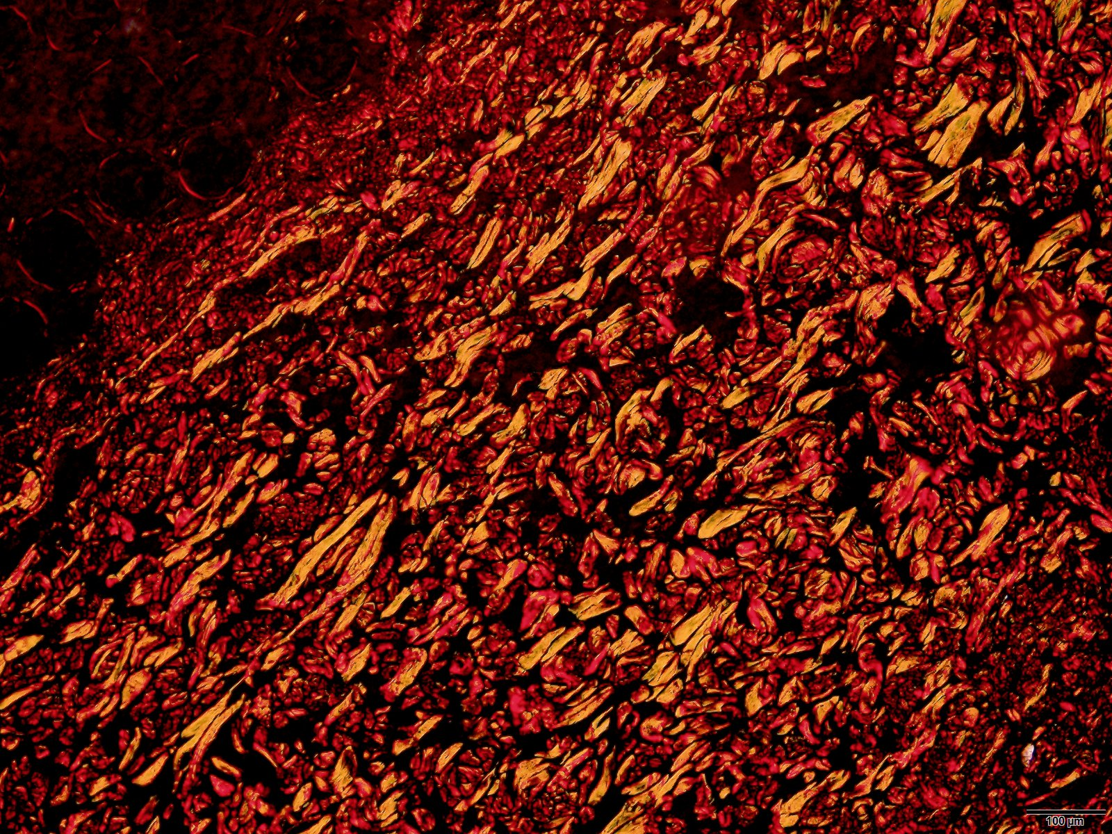

**Figure 3. Transverse sections of a loose and supple skin showing (top) fine and short collagen sheets and (bottom) collagen with red, yellow and green reflectances under polarised light in the papillary dermis**  **(PSR x 4 magnification)**

On the other hand, in the sheep with wrinkly skins, heavy deposits of hard collagen were found in the papillary dermis below the wool follicle bulbs of all 18 sheep. The hard collagen deposits also encircle the follicle bulbs, as well as surround and infiltrate the muscle bundles of layer 4 (Figure 3). Birefringence measurements of PSR stained skin sections indicate that nearly all (…. %) of the collagen sheets in the subfollicular layer of the papillary dermis have the deep red light reflectance indicative of hard (type I) collagen. (Sanaz, to provide data).

(Sanaz – could you please see if there is a loose skin PSR photo of the 4 layers similar to the one below for the wrinkly sheep but does not show the heavy collagen accumulation – photo to be inserted here)

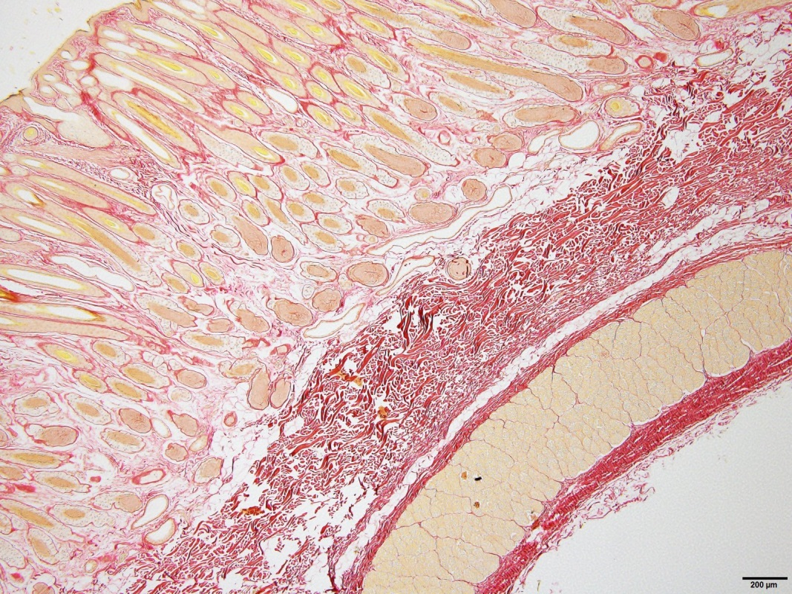

**Figure 4. Transverse sections of a wrinkly skin showing (top) thick, long and enmeshed collagen sheets and (bottom) collagen with mainly red reflectance under polarised light in the papillary dermis below the follicles of a wrinkly skin (PSR x 4 magnification).**

**Follicle and fibre disruption**

The group means for follicle, fibre and fleece traits that might be affected by hard collagen development as proposed by Jackson and Watts (2017) are shown in Table 4.

**Table 4. Mean values (and standard errors in brackets) of follicle and fibre measurements for loose skin and wrinkly skin Merino sheep. Within each flock, traits with different superscripts are highly significantly different (P<0.0001). (JW to complete measurements)**

|  |  |  |  |  |
| --- | --- | --- | --- | --- |
| Trait | Flock 6 | | Flock 7 | |
| Loose skin | Wrinkly skin | Loose skin | Wrinkly skin |
| Follicle curvature  score | 1.7a | 3.8b | 2.7a | 5.1b |
| Follicle curvature measurement |  |  |  |  |
| Follicle depth |  |  |  |  |
| Laneways | 150a (6.5) | 90b (5.3) | 151a (5.5) | 79b (5.0) |
| Follicle group orientation (CV) | 13.3a | 29.2b | 15.2a | 37.5b |
| Follicle group size |  |  |  |  |
| Dp | 16.4c (0.7) | 18.8d (0.6) | 17.7 (1.0) | 20.5 (1.0) |
| Dp SD | 2.1 (0.1) | 2.6 (0.2) | 2.5 (0.1) | 2.8 (0.4) |
| Ds | 18.4a (0.5) | 20.7b (0.6) | 18.4a (0.2) | 20.7b (0.4) |
| Ds SD | 1.9a | 2.6b | 1.9a (0.1) | 3.7b (0.4) |
| Follicle density | 83.9 (5.8) | 76.7 (4.9) | 94.9c (7.5) | 66.8d (5.8) |
| S/P ratio | 27.8c (1.5) | 21.8d (0.8) | 27.8a (0.9) | 22.6b (1.1) |
| Unfolded helices |  |  |  |  |
| O/P segmentation |  |  |  |  |
| FL | 0.56 | 0.55 | 0.48a (0.01) | 0.40b (0.01) |
| FLCV | 8.0c (0.7) | 10.9d (0.9) | 7.7a (0.8) | 14.5b (1.2) |
| Fibre emergence angle (CV) | 14.3a (0.9) | 24.0b (1.6) | 16.2a (1.3) | 25.8b (1.2) |
| Fibre nabs  (% affected fibres) |  |  |  |  |
| Staple area (mm2) | 6.7a (0.5) | 25.1b (2.4) | 13.1a (1.6) | 27.4b (2.8) |
| Sebaceous gland size |  |  |  |  |
| Sweat gland size |  |  |  |  |

Within each flock, loose and supple skin sheep differed significantly from the wrinkly sheep for the following traits. The follicles were straighter and more even in depth. The follicle groups were more widely spaced and arranged in more orderly rows. There were more secondary follicles per group (higher S/P ratio). The secondary fibres were finer and more uniform in diameter. The fibres were more uniform in length. The fleece staples were thinner. For flock 7 only, the follicle density was higher and the fibres longer. Whilst the primary fibre diameter was finer in loose and supple skin sheep, the difference was not statistically significant in either flock.

Photos of orderly vs disrupted follicle groups here (JW)

Describe extent of follicle disruption etc in wrinkly sheep (JW)

**Skin suppleness**

In both flocks 6 and 7, the papillary dermis of the loose and supple skin sheep is more supple and more compressible than the papillary dermis of the wrinkly skin sheep. The reticular dermis is also more supple and thinner in the loose skin sheep than in the wrinkly skin sheep (Table 5).

Table 5.

|  |  |  |  |  |  |  |
| --- | --- | --- | --- | --- | --- | --- |
| Flock | Sampling site | Papillary dermis | | | Reticular dermis | |
| Supple score | Compress (%) | Collagen | Supple score | Thickness  (mm) |
| 6 | loose skin | 3.8 | 74 | 271,500 | 4.3 | 1.6 |
|  | between wrinkles | 1.9 | 43 | 401,900 | 3.7 | 3.1 |
|  | on wrinkle | 2.9 | 64 | 385,600 | 3.3 | 3.1 |
| 7 | loose skin | 3.5 | 70 | 290200 | 4.4* | 2.3* |
|  | between wrinkles | 2.1 | 54 | 356,900 | 2.9 | 2.7 |
|  | on wrinkle | 1.9 | 54 | 306,500 | 2.8 | 3.5 |

* Footnote: 18 sheep sampled

In both flocks 6 and 7, the papillary dermis of the loose skin sheep is more supple and more compressible than the papillary dermis of the wrinkly skin sheep. The reticular dermis is also more supple and thinner in the loose skin sheep than in the wrinkly skin sheep.

**Skin wrinkles (including patterns)**

In all 18 examples of skin wrinkles, gross examination revealed that all of these lesions were formed within the papillary dermis (layer 2), like interlocking vertical pillars of hardened collagen. The reticular dermis (layer 3) remained supple (see Table 5) but was still firmly bound to layer 2 in all 9 examples in flock 6 and in 3 of the 9 examples in flock 7.

All of the18 wrinkly skin sheep had wrinkles originating immediately adjacent to the spinal cord in the cervical, thoracic, lumbar and sacral regions of the topline. The numbers of wrinkle lines per body region are listed in Table 6. The mean distance between the lines for each body region is also recorded.

**Table 6. Numbers of wrinkle lines per wrinkly sheep (+/- s.e) and distance between wrinkles (+ - s.e.) in flocks 6 and 7. (JW to add data)**

|  |  |  |  |  |  |
| --- | --- | --- | --- | --- | --- |
| Flock | Measurement | Body region | | | |
| Cervical | Thoracic | Lumbar | Sacral |
| 6 | No. wrinkles |  |  |  |  |
| Distance between wrinkles |  |  |  |  |
| 7 | No. wrinkles |  |  |  |  |
| Distance between wrinkles |  |  |  |  |
|  | Number of vertebrae | 8 | 12 to 14 | 5 | 5 |

(Jim Gordon is scheduled to do the skin wrinkle counts and measurements for above Table in August).

The skin wrinkling formed a distinct pattern of thin, raised lines coursing as vertical, parallel and equidistant lines down the sides of the sheep (Figure …).

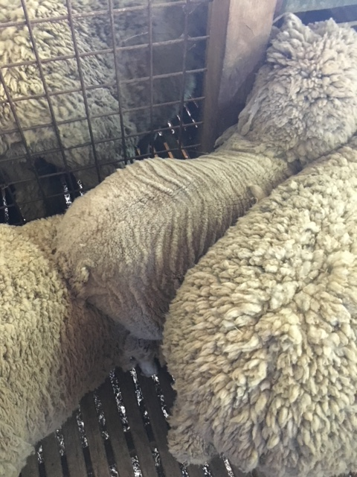

**Figure ….**

The numbers of wrinkle lines matched the number and positioning of the vertebrae in each body region. There was no difference in wrinkle counts on the left and right sides of the sheep.

**Discussion**

Wrinkly skin sheep, compared with loose and supple skin sheep, have more collagen in the papillary dermis. The collagen is mainly hard (type I) collagen. The follicles are highly curved, long and unevenly seated. There are fewer secondary follicles per follicle group. The follicle density is lower. The follicle groups are arranged in closely packed and disorderly rows. The sheep grow secondary fibres of a higher and more variable diameter and a shorter and more variable length, compared with loose and supple skin sheep. The fibres are more irregular in shape and orientation and display a bilateral asymmetry of orthocortex and paracortex (measurements on orthocortex and paracortex yet to be done). The fleece fibres are entangled and the fleece consists of much thicker staples.

These findings are consistent with Jackson and Watts (2018) hypothesis that wrinkle form when a lot of follicles initiate they expand the upper papillary dermis considerably whilst the papillary dermis below the follicle bulbs contracts due to the presence of high amounts of hard collagen. The conflict between these two tensions causes the epidermis and dermis to fold, just like a bimetal strip bending. Only sheep with both a high follicle number and a high collagen develop wrinkle. The genes for follicle number interact with the genes for collagen development. This is an epistatic effect - two sets of genes interacting. Epistatic variance of wrinkle score can be detected in analyses of quantitative variation of wrinkle scores (Jackson and Watts, 2018). It accounts for approximately 25 percent of phenotypic variation in wrinkle score (Jackson and Watts (2018)). These analyses of quantitative variation support our two component or “folding” hypothesis for wrinkle formation.

However, it is the general hardening of collagen in the papillary dermis below the follicles, and not wrinkle per se, that interferes with wool follicle development. So, it is expected that sheep can be plain bodied (wrinkle free) and still have hard collagen and impaired follicle development. If the skin is not supple and compressible, hard collagen is likely to be present. If the skin has limited dermal expansion because of low follicle numbers, wrinkles are unlikely to develop. This is what would seem to happen in Downs Wool breeds of sheep.

The reticular dermis (layer 3) of all sheep in this study remained supple and low in collagen content, and was not directly involved in wrinkle formation. However, this layer is usually retained at the base of the wrinkle (see Figure 1). It is possible that as wrinkly sheep age, or more extreme cases of wrinkly sheep are studied, that hard collagen deposition in the reticular dermis may be found.

We suggest that three developmental processes may be involved in differentiating wrinkly skin from loose and supple skin. Firstly, there may be a “trade off” process whereby certain foetal fibroblasts are committed to differentiate into prepapilla cells and wool follicles, whereas the remaining fibroblasts are committed to producing collagen and perhaps collagen of a specific type (eg. type I or type III). Secondly, there may be an “interference” process where hard collagen laid down in the foetal skin can impair secondary follicle initiation, maturation and fibre growth. Thirdly, there may be a “folding” process where the high dermal expansion accompanying high follicle initiation and excessive deposition of hard collagen in the underlying dermis create opposing tensions for skin wrinkle to develop.

We know something about the development process of the loose and supple skin sheep used in these studies. The pre-papilla cell model of Moore et al (1989) and Moore et al (1998) shows that some of the foetal fibroblasts transform into pre-papilla cells. The pre-papilla cells are then directed to aggregate as small “packages” to form many wool follicles that produce fine wool fibres of uniform diameter. This model explains why suppression of the size of primary follicles (and therefore suppression of primary fibre diameter), leads to greater numbers of secondary derived follicles (higher S/P ratio) being formed. In the loose and supple skin sheep, the fibroblasts that do not transform into pre-papilla cells, appear to be programmed to produce soft (type III ) collagen rather than hard (type I) collagen. This is what we refer to as the “trade off” hypothesis. Fibroblasts are common to collagen fibril formation and prepapilla cell formation which sets the stage for a possible “tradeoff” between collagen and follicles. The distinctly better suppleness scores and compressibility measurements for loose and supple skin sheep compared to wrinkly skin sheep suggest this is the case.

The reticular dermis (layer 3) of all sheep in this study remained supple and low in collagen content, and was not directly involved in wrinkle formation. However, this layer is usually retained at the base of the wrinkle (see Figure 1). It is possible that as wrinkly sheep age, or more extreme cases of wrinkly sheep are studied, that hard collagen deposition in the reticular dermis may be found.

Mitchell (1984) showed that if layer 4 (and layer 5) are dissected away from a skin specimen with wrinkles, the folds in layers 1 to 3 flatten out. In a wrinkly sheep, layer 4 is holding the skin under some tension, which relaxes when layer 4 is removed. Nevertheless, the published photograph of Mitchell’s dissection (Figure 5) reveals that the wrinkles are not completely removed.

Data shown here (Table 6) indicates that the pattern of skin wrinkling on the sheep’s body matches the developmental pattern set at about day 20 of embryogenesis when 31 segments known as somites develop. The dorsal portion of the somite is called a dermomyatome. Over time, the dermatome disperses to form the dermis, and the myatome, the musculature. A dermatome is an area of skin that is supplied by a single spinal nerve. There are 31 spinal nerves and 31 vertical wrinkle lines to be found in the cervical to sacral regions of the sheep’s body. It is suggested that if wrinkles are going to develop, this is most likely to occur at the points of least resistance such as the channels housing the spinal nerves and its major branches. Furthermore, collagen development must be in one dimension. If it were two dimensional the upper layers of skin would form a lump, rather than a fold.

There has been a long and often heated debate in the Merino sheep breeding community about wrinkles or folds in the skin (Austen,1943). Most breeders have insisted that Merino sheep with skin wrinkle produce more wool, presumably as a result of having greater skin surface area for growing wool. However, studies have shown that clean fleece weight is similar for both types whilst the fleece from a wrinkly sheep is less uniform owing to variations of both the diameter and length of the fibres (Spencer et al, 1928; Bosman, 1933; Belschner and Carter 1936a, 1936b; Burns, 1936; Belschner et al,1937; Bell et al, 1937; Medevbekov,1957). Furthermore, it has been clearly demonstrated that skin wrinkle markedly increased susceptibility to fly strike (Seddon et al, 1931; Belschner,1937) and reduced reproductive efficiency (Carter and Belschner,1937; Gill and Graham, 1939, 1940; Dun, 1964; Dun and Hamilton, 1965; and Drinan and Dun, 1965).

The debate was taken up by geneticists in the 1950s who set about declaring that wrinkle was a component of clean fleece weight and establishing a scoring method with photographic standards (Turner et al,1953; Turner, 1956; and Turner, 1958). This decision needs to be reversed. It may have been averted at the time had a study of the effect of collagen development on follicle development, as reported here, been undertaken, or the studies on fly strike susceptibility of Belschner and fecundity of Dun and colleagues been considered more carefully. Our view is that there should be a zero tolerance to skin wrinkle coupled with selection for loose and supple skin. One of the authors (JW) has developed a Merino sheep (referred to as”SRS”) with a loose and supple skin, completely free of skin wrinkle. He asserts that this skin type is necessary to produce fleeces of high quantity and quality (Watts et al, 2017), with the sheep being naturally resistant to fly strike and not requiring to be mulesed (Watts, 2008 a, b; Watts, 2016).

**Acknowledgements**

Sam Gordon, “Manton”, Young, New South Wales, Australia for supplying flock 7 sheep for study.

**References**

H.B. Austen (1943). The Merino. Past, Present and Probable. Grahame Book Company, Sydney.

Bell, D.S., Spenser, D.A., and Hardy, J.I. (1936). The influence of various factors upon the growth and quality of fine wool as obtainable from Merino sheep. Ohio Agric. Exp. Sta, Bull. No. 571.

Belschner, H.G. and Seddon, H.R. (1937). The classification according to susceptibility to breech strike. Scientific Bulletin of the Department of Agriculture of New South Wales, **54**: 111-122.

Belschner, H.G. and Carter, H. B. 1936a. Fleece characteristics of stud Merino sheep in relation ot degree of wrinkliness of the skin of the breech. I. *Aust. Vet. J*. **12**: 43-54.

Bogolyubsky, S.N. (1940) cited by Fraser A.S. and Short B.F. (1960). The Biology of the Fleece. Animal Research Laboratories Technical Paper No. #. CSIRO Melbourne 1960.

Bosman, V. (1933). Skin folds in Merino sheep: Influence on wool fineness and fibre variability. S. Afric. J. Sci. 30, 355-9.

Carter and Belschner 1937

Drinan, J.P. and Dun, R.B. (1965). Skin folds and Merino breeding. 3. The association between skin fold and the productivity of Merino ewes in fourteen New South Wales flocks. *Aust. J. exp. Agric. Anim. Husb.* 5 (19), 345-3

Dun, R.B. (1964). Skin folds and Merino breeding. 1. The net reproductive rates of flocks selected for and against skin fold. *Aust. J. Agric. exp. Agric. Anim. Husb.* 4:376-385

Dun, R.B. and Hamilton, B.A. (1965). Skin folds and Merino breeding. 2. The relative influence of the ram and the ewe on fertility and perinatal lamb mortality in flocks selected for and against skin fold. *Aust. J. exp. Agric. Anim. Husb.* 5 (18), 236 – 242.

Dreyer, J.H., Rossouw Ellenor and Steyn, M.G. (1982). The histology of the pre-natal follicle and hair fibre in four curl types of the Karakul sheep. S.Afr. Anim. Sci. 13 (3);180-191.

Gill, D.A., and Graham N.P.H., (1939). Studies on fly strike in Merino sheep. III. The influence of fly strike and conformation on body weightand fleece weight of Merino sheep at “Dungelear”, N.S.W. *J. Coun. Sci. Industr. Res. Aust.* **12**: 319 -29.

Gill, D. A., and Graham, N.P.H. (1940). Studies on fly strike in Merino sheep. IV. Effect of fly strike on reproduction. *J. Coun. Sci. Industr. Res. Aust.* **13**: 261-6.

Jackson, N. (2017). Genetics of primary and secondary fibre diameters and densities in Merino sheep. URL <https://github.com/nevillejackson/atavistic-sheep/mev-rewrite/supplementary/genetic-parameters/psparam.pdf>

Jackson, N. (2017). Genetic relationship between skin and wool traits in Merino sheep. Part I Responses to selection and estimates of genetic parameters. URL <http://github.com/nevillejackson/Fleece>genetics/tree/master/skinandfleeceparameters/ab3220/skinwool1.pdf

Jackson, N. and Watts, J.E. (2017). What is known about the genetics of wrinkle score in Merino sheep? URL <http://github.com/nevillejackson/Fleece-genetics/wrinkle/wrinkle.pdf>

Knight, K.R., Lepore, D.A., Horne, R.S., Ritz, M., Kumta, S. and O’Brian, B.M. (1993). Collagen content of uninjured skin and scar tissue in foetal and adult sheep. Int, J. Exp. Pathol. 74 (6):583-591.

Maddocks, I.G., and Jackson, N. (1988). Structural studies of sheep, cattle & goat skin. CSIRO Division of Animal Production.

Medevbekov, K. (1957). Productivity of Soviet Merino sheep in relation to degree of skin wrinkling (In Russian.) Dokl.Timiryazev Agric. Acad. **30** (2): 266-71.

Mercer (1950).

Mitchell, T.W., Ann Nieass, Rigby, B.J. and Snaith, J.W. (1984). Some physical and mechanical properties of sheep skin with a comparison of “thick” and “thin” skins. Wool Technology and Sheep Breeding. 22(4), 200-206.

Moore, G.P.M., Jackson, N. and Lax, J. (1989). Evidence of a unique developmental mechanism specifying both wool follicle density and fibre size in sheep selected for single skin and fleece characteristics. Genet. Res. Camb. **53**, 57-62.

Moore, G.P.M., Jackson, N., Isaacs, K. and Brown, G. (1998). Pattern and morphogenesis in skin. J. theor. Biol. **191**, 87-94.

Nay, T. (1966). Wool follicle arrangement and vascular pattern in the Australian Merino. Aust. J. Agric. Res. 17: 797-805.

Nay, T. (1973). Wool follicles – A manual for breeders. Australian Wool Corporation, Melbourne.

Seddon H.R., Belschner, H.B., and Mulhearn, C.R. (1931). Studies on cutaneous myiasis of sheep. Sheep blowfly attack. N.S.W. Dept.Agric. Sci. Bull. No. 37.

Spencer, D.A., Hardy, J.I., and Brandon, M.J. (1928). Factors that influence wool production with range Rambouillet sheep. U.S. Dept. Agric. Tech. Bull. No. 85.

Turner, Helen Newton, Hayman, R.H., Riches, J.H., Roberts, N.F., and Wilson, L.T. (1953) Physical definition of sheep and their fleece for breeding and husbandry studies: with particular reference to Merino sheep. CSIRO Div. Anim. Hlth. Prod. Div. Rept. No. 4 (Ser SW-2 mimeo)

Turner, Helen Newton (1956) Anim. Breed. Abstr. 24: 87-118.

Turner, Helen Newton (1958) Aust. J. Agric. Res. 9: 521 -52.

Watts, J.E. (2008b). Fly strike resistance. Non-mulesed Merinos within 5 years. Australian Farm Journal. pp. 52-55.

Watts, J.E. (2016). No mulesing and no fly strike. In Redesigning Animal and Fibre Genetics in Merinos, Angoras and Alpacas. Your guide to the science behind SRS® breeding and selection. Edited by Patrick Francis, August 2014, pp.29-30.

Watts, J.E., Jackson, N. and Ferguson, K.A. (2017). Improvements in fleece weight and wool quality of Merino sheep selected visually for high fibre density and length. URL[https://github.com/nevillejackson/SRSMerino/Paper](https://github.com/nevillejackson/SRS-Merino/Paper).2.Revised.10.November.2017.docx